# **The Federal Deposit Insurance Corporation (FDIC)**

The mission of the Federal Deposit Insurance Corporation (FDIC) is to maintain stability and public confidence in the nation's financial system. In support of this goal, the FDIC:

* [Insures deposits](https://www.fdic.gov/deposit/deposits/),
* [Examines and supervises financial institutions](https://www.fdic.gov/resources/bankers/) for safety and soundness and consumer protection,
* Works to make large and complex financial institutions [resolvable](https://www.fdic.gov/resources/resolutions/), and
* [Manages receiverships](https://www.fdic.gov/resources/resolutions/bank-failures/).

An independent agency of the federal government, the FDIC was created in 1933 in response to the thousands of bank failures that occurred in the 1920s and early 1930s

The FDIC is headquartered in Washington, DC, and has established offices around the country.

The FDIC is managed by a five-person [Board of Directors](https://www.fdic.gov/about/learn/board/) that includes the Comptroller of the Currency and the Director of the Consumer Financial Protection Bureau, all of whom are appointed by the President and confirmed by the Senate, with no more than three being from the same political party.

Deposit Insurance Coverage

Total Insured Deposits: The total insured deposits have been increasing steadily over the years, from $14.4 trillion in 2020 to $15.1 trillion in 2022. This indicates a growing trend in the number of insured deposits.

Number of Insured Deposits: The number of insured deposits has also been increasing, from 93.4 million in 2020 to 95.1 million in 2022. This suggests that more individuals and institutions are participating in the FDIC's deposit insurance program.

# **The Office of the Comptroller of the Currency (OCC)**

is an independent bureau of the U.S. Department of the Treasury. The OCC charters, regulates, and supervises all national banks, federal savings associations, and federal branches and agencies of foreign banks.

They ensure that the banks they supervise operate in a safe and sound manner, provide fair access to financial services, treat customers fairly, and comply with applicable laws and regulations. The OCC receives no appropriations from Congress.

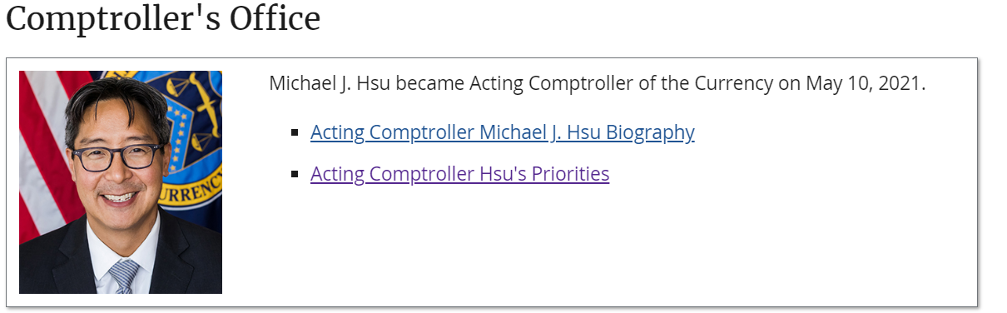

Departments & Offices

The OCC carries out its mission through a number of departments and offices under the leadership of the Comptroller and senior deputy comptrollers.

OCC Through the Years:

OCC History 1863-1865

Founding of the National Banking System

The story of the Office of the Comptroller of the Currency and the national banking system begins in 1863, when the National Currency Act was passed by Congress and signed into law by President Abraham Lincoln.

1866 - 1913

The System in Operation

Of the 1,600 state banks that existed in 1860, only 300 remained by 1866, while the national banking system shot ahead in numbers and influence.

1914 - 1935

Years of Transition

The passage of the Federal Reserve Act in 1913 was a watershed in U.S. banking history. It created the Federal Reserve System, with a network of branches in large American cities, tied together by a Board of Governors.

1936 - 1966

Stabilization & Challenge

World War II signalled the end of the Great Depression. National service pulled many bank examiners off the front lines of supervision and moved them to the front lines of combat. Fortunately, with the emphasis on lending to government rather than individuals, bank safety and soundness was never compromised.

1967 - 2007

Information Revolution, Prosperity, Warnings

The closer integration of America and the world brought changes to the OCC as well as to the industry it supervised. Communication improvements meant faster and more consistent decision making across the OCC.

2008 – Present

Crisis, Reform, and Recovery

Despite the warning signs, no one expected the worst financial crisis since the Great Depression. The year 2008 saw the first ever annual decline in housing prices, along with record foreclosure levels and heavy losses on subprime loans.

# **Functions of the Federal Reserve System (FRS)**

**Implementing Monetary Policy:** The FRS sets monetary policy to achieve maximum employment, stable prices, and moderate long-term interest rates. It does this by adjusting the federal funds rate, which influences market interest rates and, in turn, US economic activity.

**Regulating Banking Institutions:** The FRS supervises and regulates banking institutions to ensure the safety and soundness of the US banking and financial system, as well as to protect consumers' credit rights.

**Maintaining Financial System Stability:** The FRS works to maintain financial system stability by monitoring risk across the financial system, conducting macroprudential supervision and regulation of large, complex financial institutions, and engaging in domestic and international cooperation and coordination.

**Providing Financial Services:** The FRS provides financial services to depository institutions, the U.S. government, and foreign official institutions. It operates the national payments system, maintains accounts for depository institutions, and facilitates transactions involving the U.S. government.

**Structure of the Federal Reserve System**

**Board of Governors:** The Board of Governors, also known as the Federal Reserve Board (FRB), is the central governing body of the FRS. It consists of seven members nominated by the President of the United States and confirmed by the U.S. Senate. The Board is responsible for setting monetary policy and overseeing the FRS.

**Federal Reserve Banks:** There are 12 regional Federal Reserve Banks, each with a president responsible for a specific geographic area. These banks regulate and oversee privately-owned commercial banks, and nationally chartered commercial banks are required to hold stock in and can elect some board members of their regional Federal Reserve Bank.

**Federal Open Market Committee (FOMC):** The FOMC is the monetary policy-making body of the FRS. It consists of the seven members of the Board of Governors, the president of the New York Fed, and four regional Fed presidents. The FOMC sets monetary policy by adjusting the target for the federal funds rate.

**Key Components of the Federal Reserve System**

**Federal Funds:** Federal funds are the reserve balances that private banks keep at their local Federal Reserve Bank. These balances are the basis for the FRS's monetary policy work, as they influence how much interest private banks charge each other for lending.

**Federal Reserve Accounts:** Federal reserve accounts contain federal reserve credit, which can be converted into federal reserve notes. Private banks maintain their bank reserves in these accounts.

**National Payments System:** The FRS plays a crucial role in the U.S. payments system, providing financial services to depository institutions and facilitating transactions involving the U.S. government. It operates the Fedwire Funds Service, Fedwire Securities Service, and the National Settlement Service, among other payment systems